1.

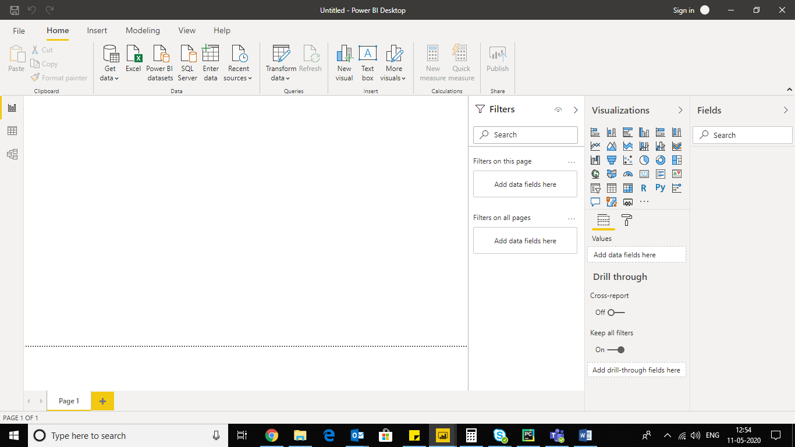

2.

Report view

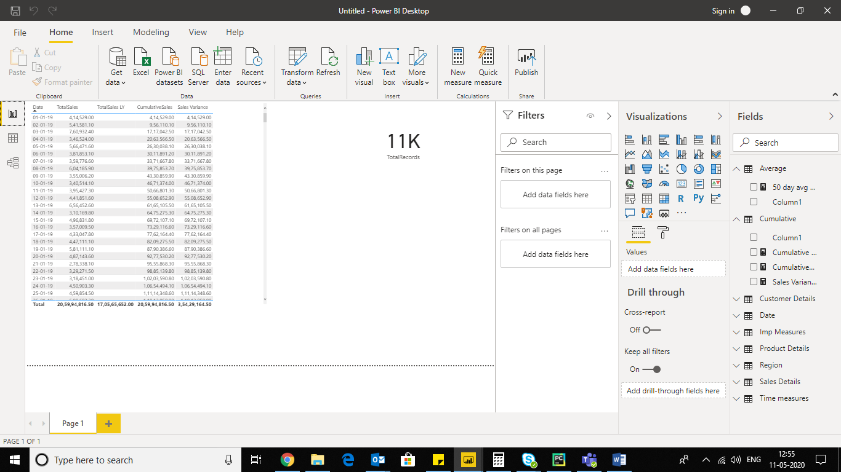

Data view

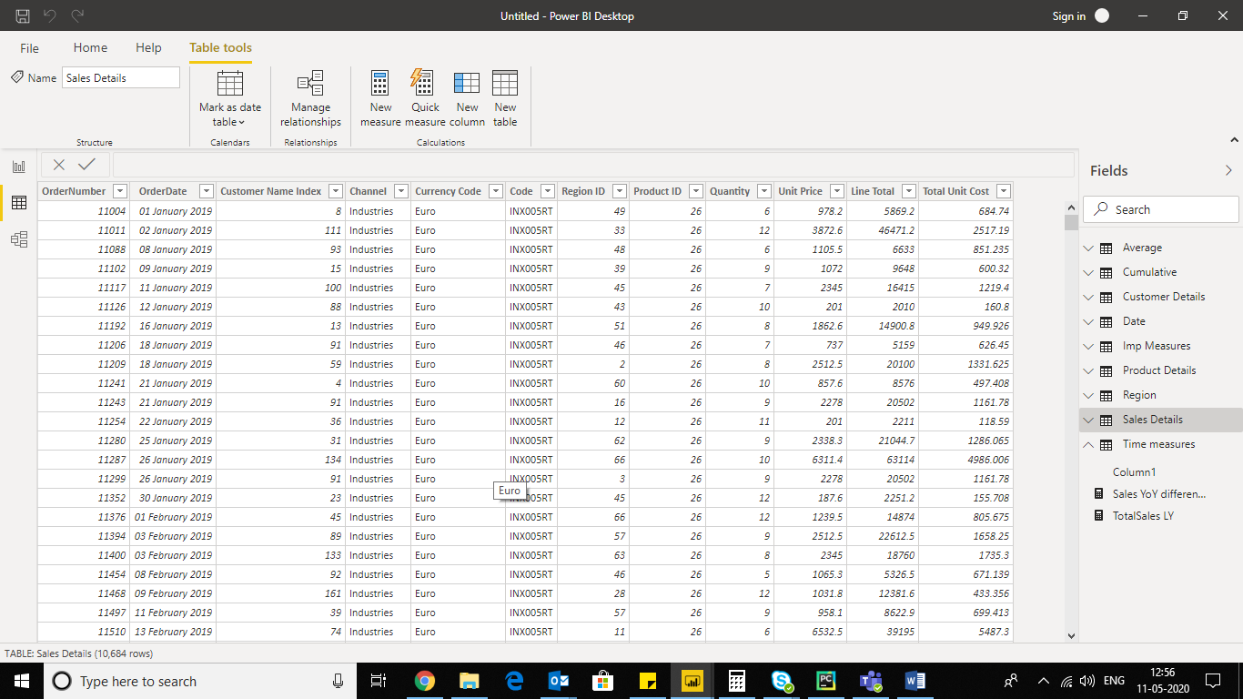

Model view

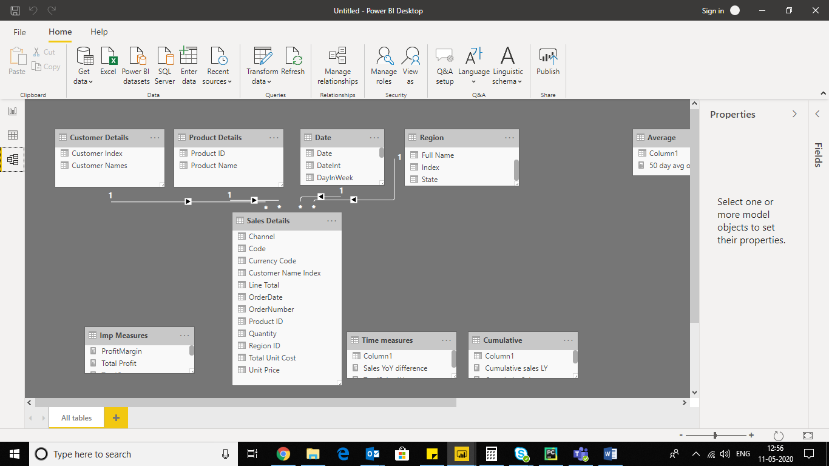

Power query editor view

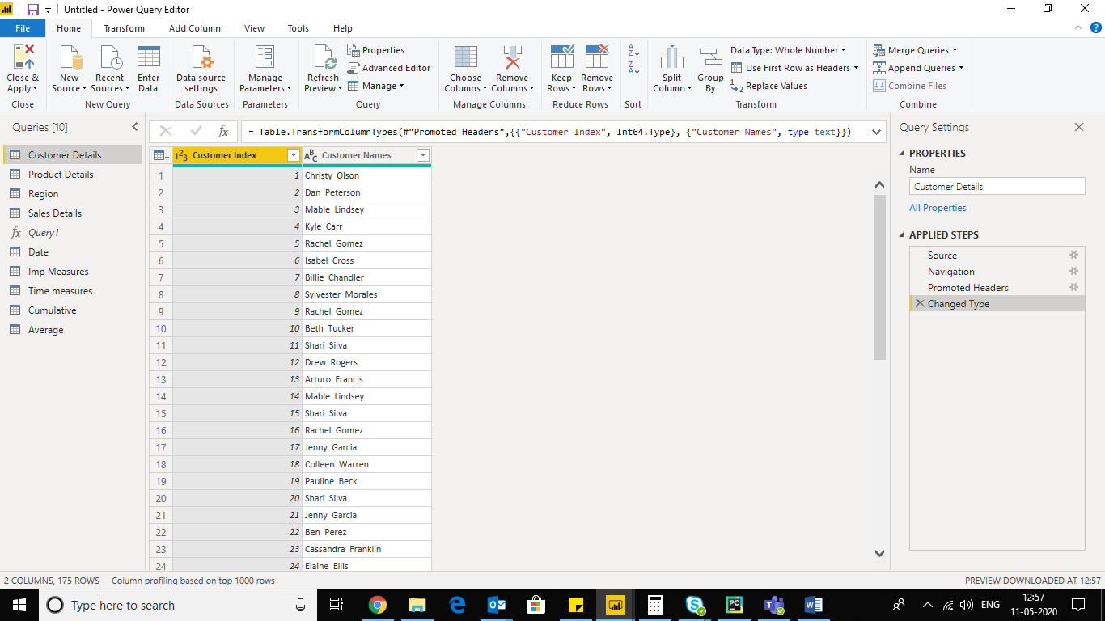

Advance editor

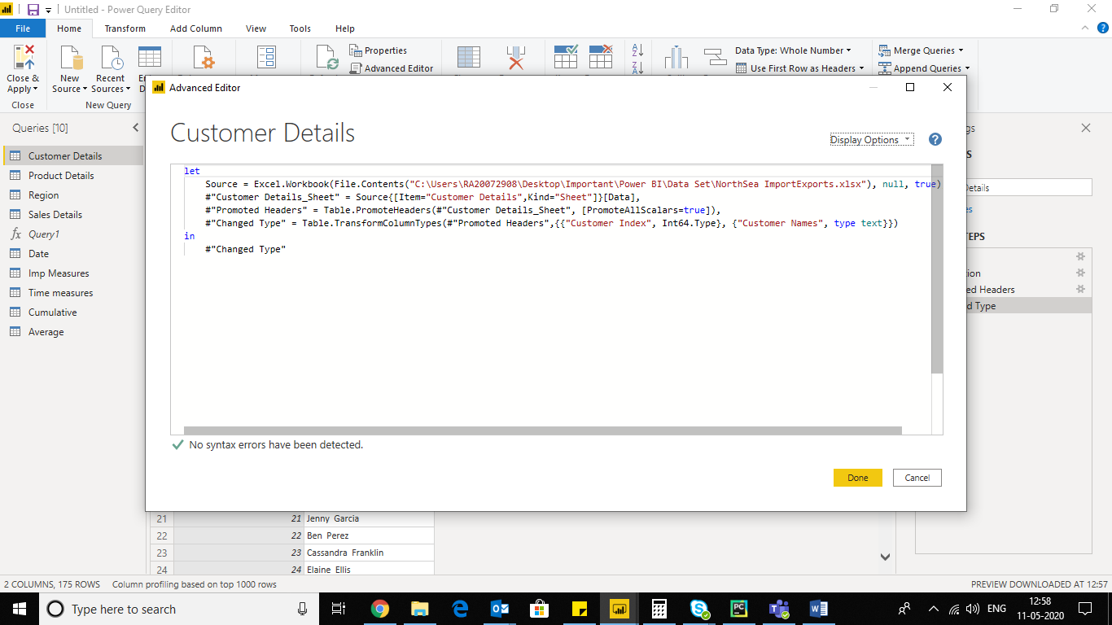

3.

**Power BI Desktop:** *It* is a **free application** you install on your local computer that lets you connect to, transform, and visualize your data. With Power BI Desktop, you can connect to multiple different sources of data, and combine them (often called modelling) into a data model. This data model lets you build visuals, and collections of visuals you can share as reports, with other people inside your organization. Most users who work on business intelligence projects use Power BI Desktop to create reports, and then use the Power BI service to share their reports with others.

**Power BI Pro:** Power BI Pro is an individual user license that lets users read and interact with reports and dashboards that others have published to the Power BI service. Users with this license type can share content and collaborate with other Power BI Pro users. Only Power BI Pro users can publish or share content with other users or consume content that's created by others, unless a Power BI Premium capacity hosts that content.

**Price of Power BI Pro is 660 rupees/month/user**

**Power BI Premium: Power BI Premium** is a capacity-based offering that includes: Flexibility to publish reports broadly across an enterprise, without requiring recipients to be licensed individually per user. Greater scale and performance than shared capacity in the **Power BI** service

**Price of Power BI Premium is 3,30,190 rupees Monthly price per dedicated cloud compute and storage resource with annual subscription**